

【Artisan Category】Entry Form

Please read carefully the following instructions and fill in the form on the back page.

【Entry Period】Jars must arrive by between 1st of March and 14th of April.

【Entry Address】〒796-8501　Marmalade Awards & Festival Planning Division,

Yawatahama City Office, Kitahama 1-1-1, Yawatahama City,

Ehime Prefecture, Japan

※All the necessary entry fees must be paid by entrants. Please carefully package jars

when sending.

※We store jars at room temperature. While care will be taken to ensure the safe keeping of all entries throughout judging, the organisers and judges cannot be held responsible for any loss or damage to entries.

※Please understand we don’t accept any inquiries or complaints on judging results.

Final check-list before entering your jars

□One jar is for judging, so put a label on the side of jar with just marmalade name, category name, all ingredients and production date. Make sure judges do not recognise the company or brand (including lid). The other is for sample tasting at the Festival, so send it as packaged for sale.

□The volume of judging jar has to be between 110g and 450g.

□Fill marmalade to 1cm below the rim of the jar.

□Use transparent glass jar.

□Please note that we don’t return entries.

□Choose a category.

②Multiple Citruses Marmalade

Use multiple citrus fruits

①Single Citrus Marmalade

Use one kind of citrus

③Mixed Marmalade

Use citrus and other ingredients

Ex)：Vegetables, Alcohols, other fruits

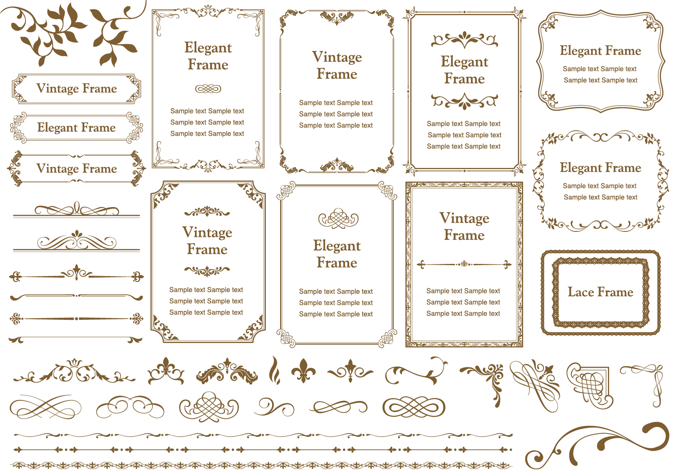

＊Winners can use the Award roundel for sale for a period of 3 years.

＊We will advertise awards-winning marmalades through various medias to

support your sales expansion.

※UK awards roundel



Marmalade Awards & Festival Planning Division,

Yawatahama City Office TEL：+81-894-22-3117

**Please fill in the form and send it with your marmalade jars!**

**For Official Use**

Company Name：

企業・団体名欄

チェック

Address：〒

Department：　　　　　Position：　　　　Person in Charge：

Phone：　　　　　　　　　　　　　E-mail：　　　　　　　　＠

Website（if any）：

Facebook/Twitter/Instagram（if any）：

◆Choose a category and fill in the thick-bordered box

原材料記載

チェック

|  |  |  |
| --- | --- | --- |
| Category | Ingredients | # of entries |
| ①Single Citrus Marmalade  瓶の側面  マーマレード名、  カテゴリー名、  原材料名、及び製造年月 |  |  |
| ②Multiple Citruses Marmalade |  |  |
| ③Mixed Marmalade  【審査用】  【試食用】  出品数  チェック |  |  |
| Total Entries | |  |

◆Calculate the entry fee and fill in the thick-bordered box

審査用・試食用の

２瓶あるか。

|  |  |  |
| --- | --- | --- |
| Fee  金額  チェック  4,000JPY for 1st jar and 3,000JPY for further entries | Ex：３entries  4,000JPY(1st ar)＋3,000JPY(2nd jar)＋3,000JPY(3rd jar)＝10,000JPY | JPY |

◆Payment Method

Please choose one of the two accounts and make a payment within

7 days after entering your jars. All the fees including transfer fee

must be paid by entrants. The fees will not be refunded.

振込口座

チェック

事務局受付

№

|  |  |  |
| --- | --- | --- |
| BANK NAME | THE IYO BANK,LTD. | THE EHIME BANK,LTD. |
| SWIFT CODE | IYOBJPJT | HIMEJPJT |
| BANK CODE | 0174 | 0576 |
| BRANCH CODE | 300 | 044 |
| BRANCH NAME | YAWATAHAMA BRANCH | YAWATAHAMA BRANCH |
| BRANCH  ADDRESS | 380-1 YAWATAHAMA  EHIME JAPAN | 1355-2 YAWATAHAMA EHIME JAPAN |
| ACCOUNT No. | 1894553 | 3958436 |
| ACCOUNT  NAME | Ueki Imaoka, The Executive Director of Committee for  The Dalemain World Marmalade Awards & Festival in Japan | |
| ADDRESS | 1-1-1 KITAHAMA YAWATAHAMA EHIME JAPAN | |
| TELEPHON No. | +81-894-22-3117 | |