

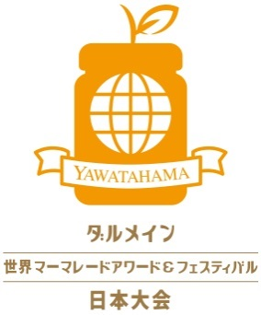

【Homemade Category】Entry Form

Please read carefully the following instructions and fill in the form on the back page.

【Entry Period】Jars must arrive by between 1st of March and 14th of April.

【Entry Address】〒796-8501　Marmalade Awards & Festival Planning Division,

Yawatahama City Office, Kitahama 1-1-1, Yawatahama City,

Ehime Prefecture, Japan

※All the necessary entry fees must be paid by entrants. Please carefully package jars

when sending.

※We store jars at room temperature. While care will be taken to ensure the safe keeping of all entries throughout judging, the organisers and judges cannot be held responsible for any loss or damage to entries.

※Please understand we don’t accept any inquiries or complaints on judging results.

Final check-list before entering your jars

□Citrus peels are visible?

Important for good marmalades

□The volume of jar is between 110g and 450g?

□Fill marmalade to 1cm below the rim of the jar?

□Use sterlised jars, deaerate and sterlise jars after filling marmalade?

□Choose a category?

②Multiple Citrusus Marmalade

Use multiple citrus fruits

①Single Citrus Marmalade Use one kind of citrus

③Mixed Marmalade

Use citrus and other ingredients Ex：Alcohols, tea

⑤High School Students’Marmalade

Those at high school

④Children’s Marmalade

Under 15 years old

⑥Senior Marmalade

75 years old

and over



⑨Homemade Citrus marmalade

Citrus you grew at home

Or your farm

⑦Men’s Marmalade

For men

⑧Family Marmalade

Family-makers



図1

⑫Savoury Food marmalade

To serve with fish

（let us know what fish）

⑩Ehime Citrus Marmalade

Using citrus from

Ehime

⑪Black Marmaladeの黒いBlack(ish)-coloured

Marmalade

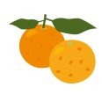

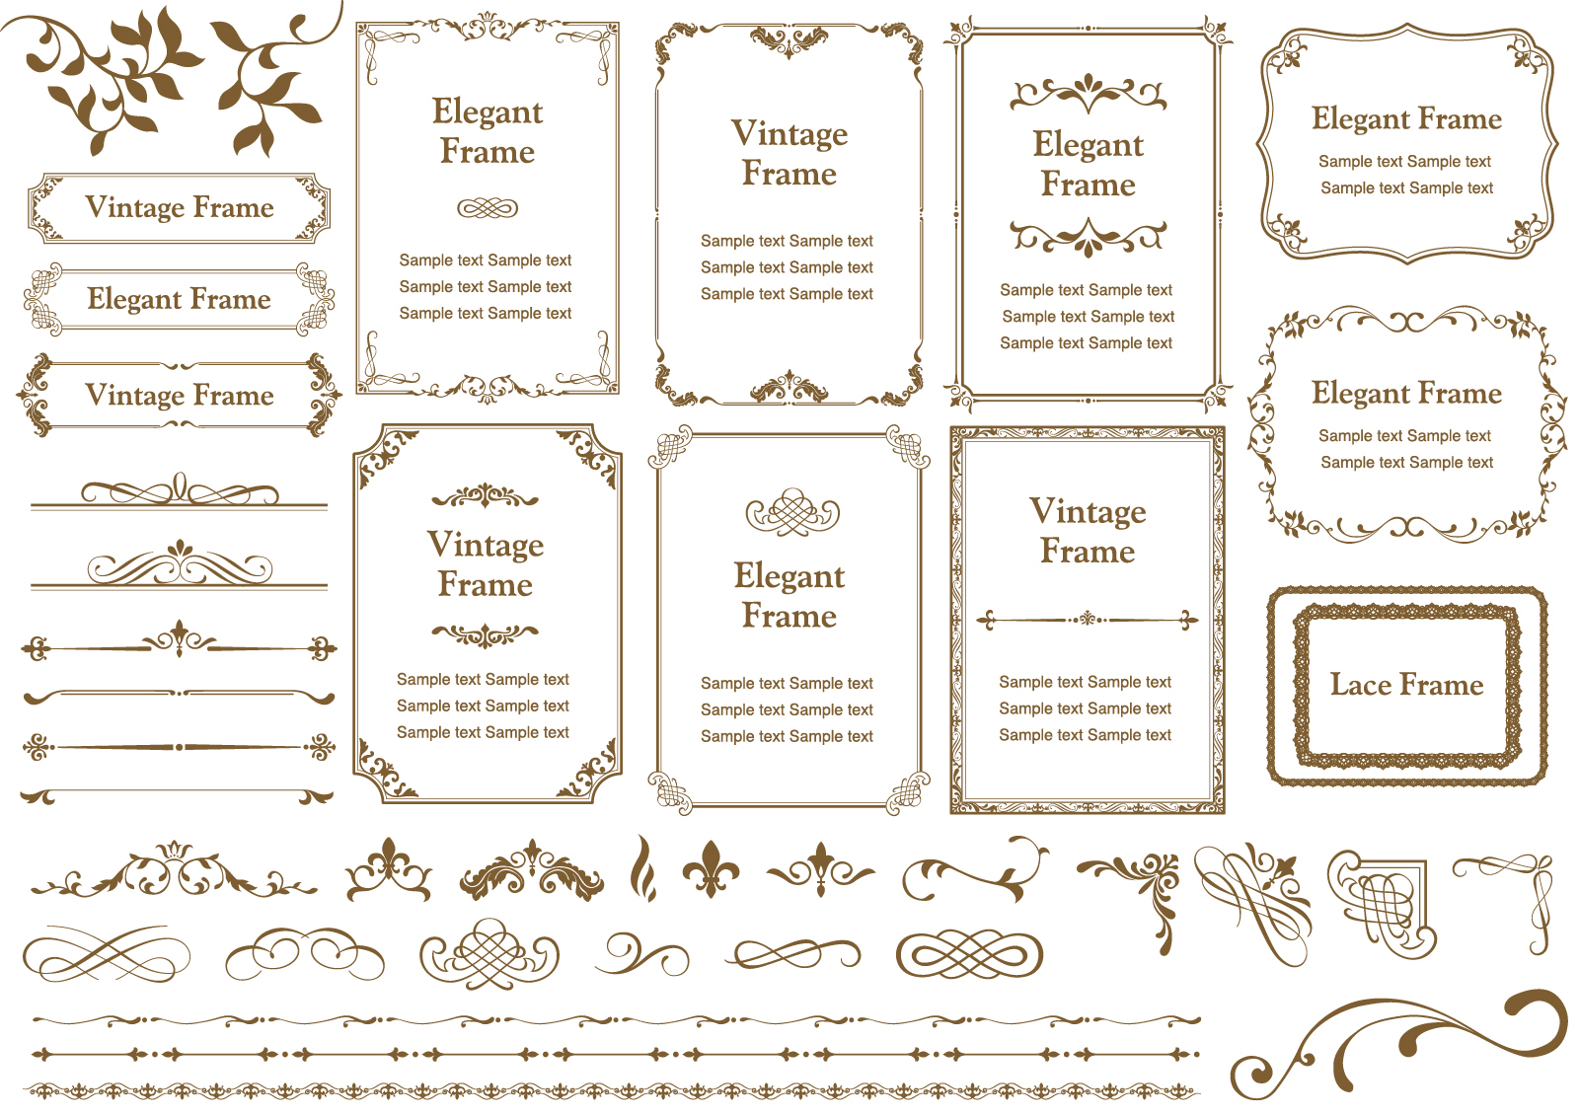

We will advertise award-winning entrants through various medias, as well as consider to support merchandising your marmalades.



Marmalade Awards & Festival Planning Division,

Yawatahama City Office TEL：+81-894-22-3117

**Please fill in the form and send it with your marmalade jars!**

**For Official Use**

受取場所・日時

Name：　　　　　　　　　　　　　　 　　　 Sex： 　　Age：

Address：〒

氏名欄

チェック

Phone：　　　　　　　　　　　　E-mail：　　　　　　　　＠

瓶の底面

氏名・電話番号

Facebook/Twitter/Instagram（if any）：



◆Choose a category, tell us the citrus you use and the number of entries.

|  |  |  |
| --- | --- | --- |
| Category Number | Citrus | # of entries |
| 原材料記載  チェック |  |  |
| 瓶の側面  原材料名・  製造年月日 |  |  |
|  |  |  |
|  |  |  |
| Total entries | |  |

◆Calculate the entry fee and fill in the thick-bordered box

|  |  |  |
| --- | --- | --- |
| Fee  金額  チェック | 1,500JPY　×　entries | JPY |

◆Payment Method

Please choose one of the two accounts and make a payment within

振込口座

チェック

7 days after entering your jars. All the fees including transfer fee

must be paid by entrants. The fees will not be refunded.

振込口座

チェック

|  |  |  |
| --- | --- | --- |
| BANK NAME | THE IYO BANK,LTD. | THE EHIME BANK,LTD. |
| SWIFT CODE | IYOBJPJT | HIMEJPJT |
| BANK CODE | 0174 | 0576 |
| BRANCH CODE | 300 | 044 |
| BRANCH NAME | YAWATAHAMA BRANCH | YAWATAHAMA BRANCH |
| BRANCH  ADDRESS | 380-1 YAWATAHAMA  EHIME JAPAN | 1355-2 YAWATAHAMA EHIME JAPAN  事務局受付  № |
| ACCOUNT No. | 1894561 | 3958532 |
| ACCOUNT  NAME | Ueki Imaoka, The Executive Director of Committee for  The Dalemain World Marmalade Awards & Festival in Japan | |
| ADDRESS | 1-1-1 KITAHAMA YAWATAHAMA EHIME JAPAN | |
| TELEPHON No. | +81-894-22-3117 | |